**Project-4:**

Question 1:

// ComputeMethods.java

public class ComputeMethods {

// Method to convert Fahrenheit to Celsius

public double fToC(double degreesF) {

double celsius = (degreesF - 32) * 5.0 / 9.0;

return celsius;

}

// Method to calculate the hypotenuse of a right-angled triangle

public double hypotenuse(int a, int b) {

double hypotenuse = Math.sqrt(a * a + b * b);

return hypotenuse;

}

// Method to simulate rolling a six-sided die

public int roll() {

int dieRoll = (int) (Math.random() * 6) + 1;

return dieRoll;

}

// Main method for testing purposes

public static void main(String[] args) {

// Create an instance of ComputeMethods

ComputeMethods cm = new ComputeMethods();

// Invoke the fToC method and display the result

double tempF = 100.0;

double tempC = cm.fToC(tempF);

System.out.println("Temperature in Celsius: " + tempC);

// Invoke the hypotenuse method and display the result

int sideA = 3;

int sideB = 4;

double hypotenuse = cm.hypotenuse(sideA, sideB);

System.out.println("Hypotenuse: " + hypotenuse);

// Invoke the roll method and display the result

int rollResult = cm.roll();

System.out.println("Rolled a die: " + rollResult);

}

}

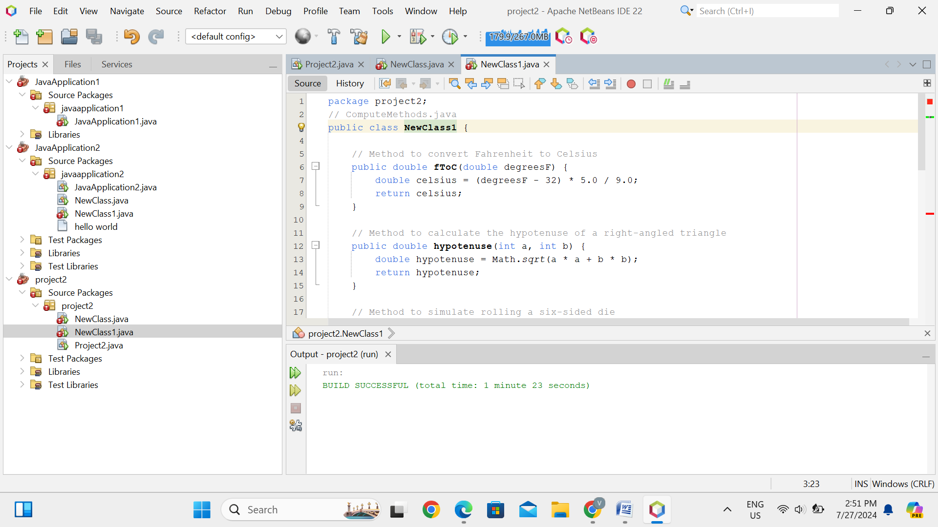

Question 2:

public class ProcessName {

public static void main(String[] args) {

// Hardcoded name for demonstration

String fullName = "Jenny Weaver";

// Extract the first and last name

String[] nameParts = fullName.split(" ");

String firstName = nameParts[0];

String lastName = nameParts[1];

// Get the first initial of the first name

String firstInitial = firstName.substring(0, 1);

// Display the name in the specified format

System.out.println("Your name is: " + lastName + ", " + firstInitial + ".");

}

}

